## merchant

Demo date: Oct 2nd, 2024  
Scoping start date: Sep 30, 2024

MSA Signature Date: Nov 7, 2024  
Onboarding Kick Off Date: Nov 13, 2024

Go Live Date: Dec 12, 2024

GTM POC: Nick  
Implementation POC: Arjun

ERP: QBO

Tax Integration: QBO Hard Coded Taxes

### 

### Key people at Merchant

* Account Receivable POC: Jemima Law, Head of BizOps
* Billing POC: Mary Huang, Chief Commercial Officer - https://www.linkedin.com/in/maryhuan9/

### Accountant: Joy Hu, CPA at Attivo

### 

| Notes Sections [Ops International Team to Ignore] *(AE/ Implementation to fill)*   * Flat Platform Fee and Tiered unit pricing for Active Clients * Is there any important merchant relationship information?  1) What is the merchant temperament? * Mary worked with Arjun at Peloton. Easy people to work with - intelligent 2) Is there a key POC: (i.e.: who is the buyer/decision maker?) * Mary and Jemima 3) What are the Tabs features that the key POC cares about? * Usage billing. Renewals Management. Reporting |
| --- |

### 

### Company summary *(AE to fill)*

Luminary is a technology platform that automates the complex and inefficient estate planning process. The platform can streamline execution complexity and manual workflows, reducing risk, and expanding opportunities for use. The company was founded in 2022 and is headquartered in New York.

Goals (North star)  
*(AE/ Implementation to fill)*

~~Just got rid of their outsourced accounting firm.~~ Rev Ops now falls under Jem - who does not have a finance background. Scaling quickly and need one system to manage finances. Buying Tabs to automate all of their revenue workflows

Is there an opt out clause? If so, what is the merchant looking for so they do not exercise it?  
No

### Billing model *(AE/ Implementation to fill)*

* Are there unique things about the customer creation process for this merchant?
  + N/A
* Information on how merchant bills
  + Flat Platform Fee pre-determined or prorated by number of seats and Tiered pricing for # of active clients
* How contract is broken up
  + 2 Page contract around subscription and payments

### Contract Processing Steps *(Implementation/Success to fill)*

### 

### 

1. **Billing POC Name, Email and Address**
   1. 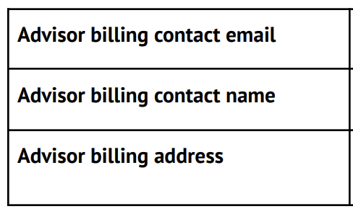
   2. Pls ensure this info is used when creating customers
   3. If contract has no info, create customer with any available information.
2. **Steps to process**

**US TEAM ONLY: Make sure the Customer Name is correct based of the Advisor Name.   
 - Please ping** [**Ashni Walia**](mailto:awalia@tabsplatform.com)**and** [**Marshall Morrison**](mailto:marshall@tabsplatform.com)**once processed.**

* 1. **Subscription SKU** may extend across multiple years.   
     If the number of user seats changes, each rev schedule should only be as long as the billing schedule.   
     If the number of seats stays the same across multiple billing schedules, the revenue schedules should extend for the duration of the total billing schedules.   
     For example, in the picture below this would be a RS/BT for Y1, a different RS/BT for Y2, and a third RS/BT for Y3. The rev schedules would ***not*** be Y1-3. This is necessary to show an increase in GAAP revenue across the periods which is important to the CEO.
  2. For flat fees, please ensure to **bill first of period.**
  3. 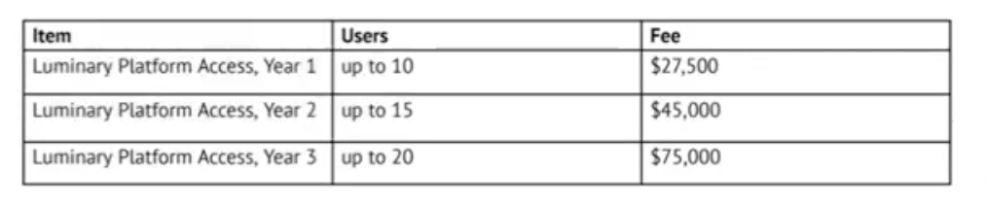
  4. Item Description for anything that is a Luminary Platform Access:
     1. Include **authorized users** and **active clients.** See screenshot below for where to find
     2. 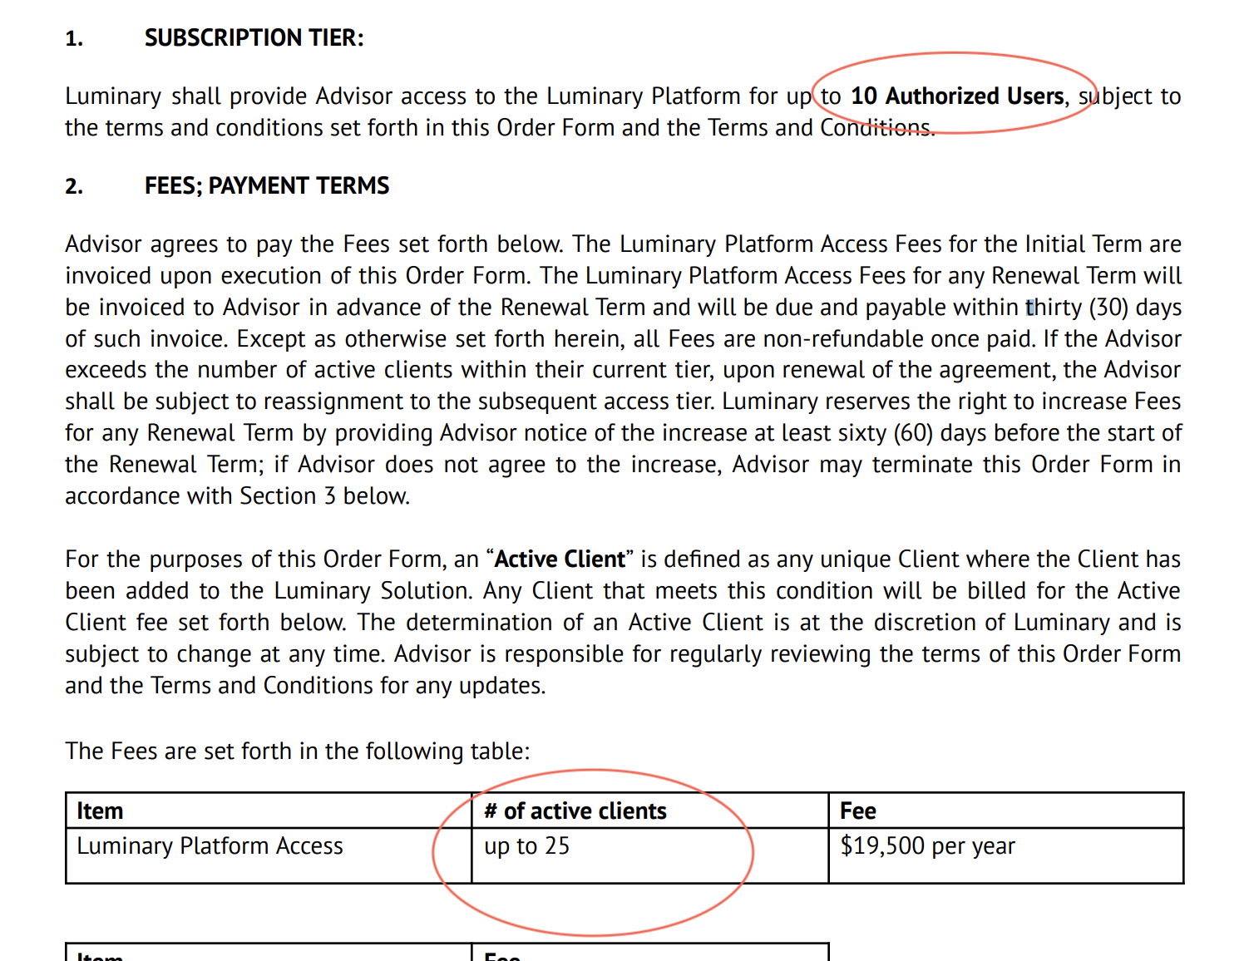
  5. If there is an overage cost for the number of “users” (or “households” or “plans”), create a billing term for the overage and assign the event “**Additional Users**”. (this will always be a unit price BT)
     1. If there is no overage price for the number of users, there is no usage-based billing term for users.
     2. **Note that Additional Users should create a billing team that is recurring each month but priced for the entire term. That is, $500 for additional users for the entire term in the screenshot below.**
     3. When an additional user is added, the Merchant will create usage data that accounts for the partial term being added (e.g. 0.75 for 9 months) and will upload it.
     4. All additional users are billed on the calendar month.
        1. If a deal is signed on May 15th, the Subscription SKUs would be billed May 15th for the period May 15, 2024 - May 14, 2025 and the Additional User item would be billed June 1, recurring monthly for 12 months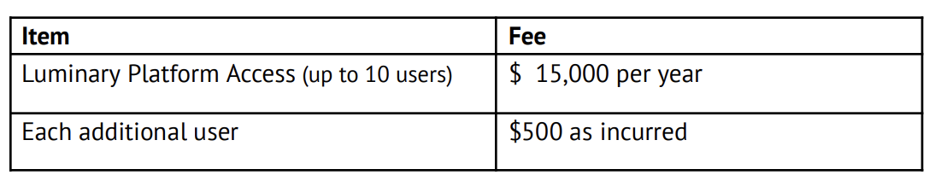
  6. **Solution Tier billing item should always be a quantity of 1.** Ignore the number of authorized users

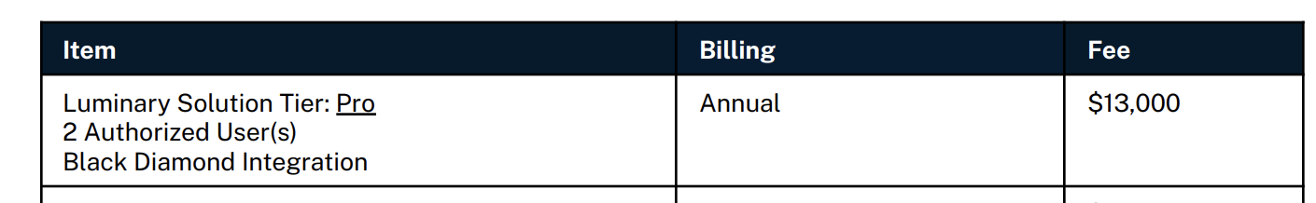  
  
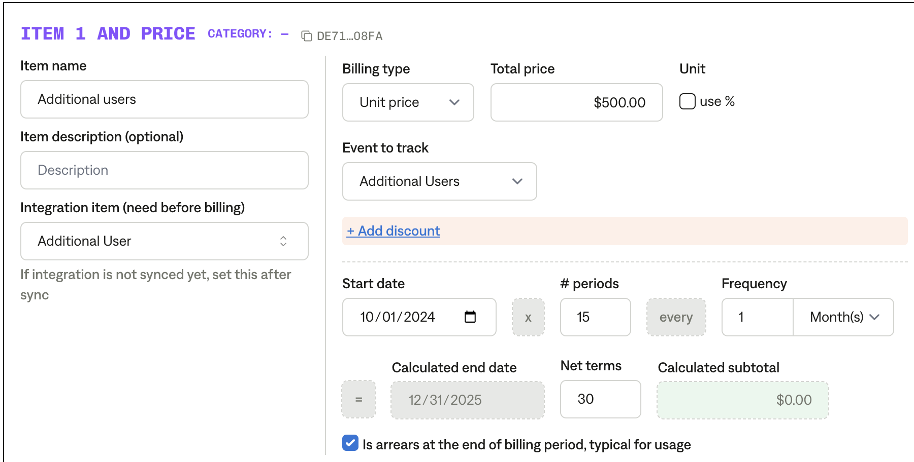

* 1. **Number of clients SKU**Many contracts bill by the number of active clients (customers). These may be priced at $x each year which means they should look like this: (NOTE that I have priced this QUARTERLY by dividing by 4)  
       
     This product is always billed on the calendar quarter which means its billing terms should be starting January 1 recurring every 3 months. Replace January with April, July, or September as needed, but it should always be one of those 4 dates. 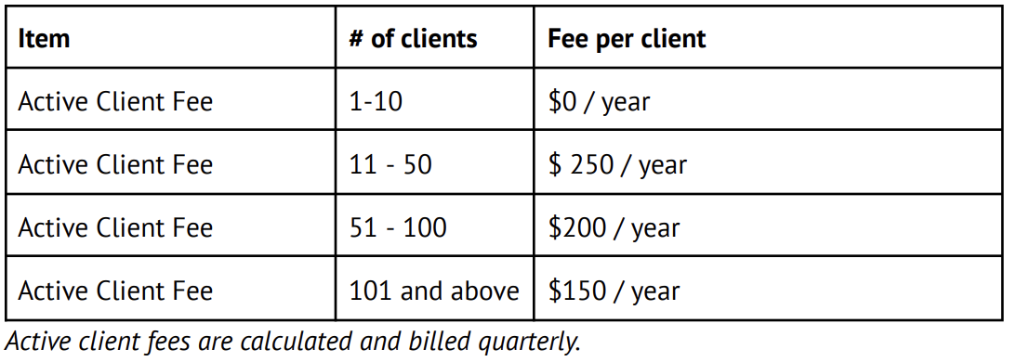  
       
     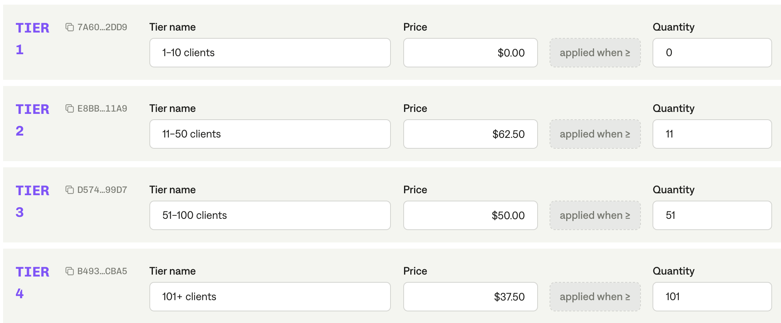

1. Anything to ignore in contracts?
   1. None
2. Specifics processing things the merchant has requested that may differ by contract (e.g. always back-date invoice date to final day of the month)
   1. None
3. Default Service Term
   1. Default 1 year
4. Default Net Payment Terms
   1. Default 30 days
5. Default Billing Frequency
   1. Default is **Annual** for subscriptions, **Quarterly** for active client fee, and **Monthly** for number of users
6. How do we handle taxes as a line item?
   1. No extra tax line item. Taxes are computed by Quickbooks AST.

### Events Processing and Integration Items Processing (if necessary) *(Implementation/Success to fill)*

| **Item Name** | **Integration item** | **Event to track** |
| --- | --- | --- |
| Luminary Platform Access or any other subscription as shown in contract | Luminary Builder Platform Access |  |
| SSO integration | SSO integration |  |
| Additional users | Additional User | Additional Users |
| Active client fee | Active Client Fee | Active Clients |

Post Processing Communications (if necessary)  
*(Implementation/Success to fill)*

* Does the Ops Team need to notify anyone on the team re: completion of processing batches in Implementation or Active phase?
  + Message in #luminary and CC [Arjun Gopalratnam](mailto:arjun@tabs.inc). Only necessary for Dec 2024 – Feb 2025. After that, no communication needed.

### Customer Information *(Implementation/Success to fill)*

* Any important information on specifics customers of this merchant
  + None

### Feature Requests *(AE/Implementation/Success to fill)*

* Hubspot Customer Data syncing to Tabs
  + Currently use HS as the source of truth for revenue and want to have Tabs act as a CRM for their customers

### Rewatch Calls *(AE/Implementation/Success to fill)*

* Intro Call 9/30/24
  + <https://tabs.rewatch.com/video/k7fq9guhdnw465z0-mary-and-rebecca-schwartz-tabs-september-30-2024>
* Custom Demo 10/2/24
  + <https://tabs.rewatch.com/video/ukg5affvd9fpoeff-luminary-tabs-custom-demo-october-2-2024>

Notes

* Usage data sheet: [Luminary / Tabs usage template](https://docs.google.com/spreadsheets/d/1RsqR3dODGRvzzGge3o3gL0T8h1u5jOuSxez-3ehTyoE/edit?gid=838486643#gid=838486643)
* Using docusign forwarding for new deals